Computer Science SPINNING ACTOR Lab Value - 100

Lab Goal : This lab was designed to teach you more about the GridWorld case study and more about the methods of the Actor class.

Lab Description : Extend the Actor class to make a SpinningActor that will not move, but simply sit in the same location forever and spin. SpinningActor will rotate in 45 degree increments.

Sample Data :
Files Needed ::
SpinningActor.java
SpinningActorRunner.java
GridWorld Project

none

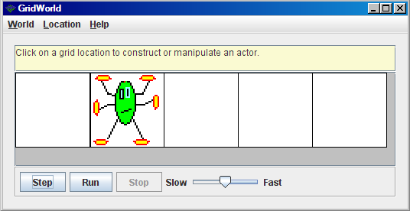
Sample Output :
Image Information
You can create an image for any class you create in GridWorld.
The image must have the exact same name as the class. Case matters!
Save the image in the same folder as the class.

public class FlyingActor .....
FlyingActor.gif

The best size for an image would be 48X48.

To make your own image for the SpinningActor class, you would have to name the image SpinningActor.gif and save the image in the same folder as the SpinningActor class.

